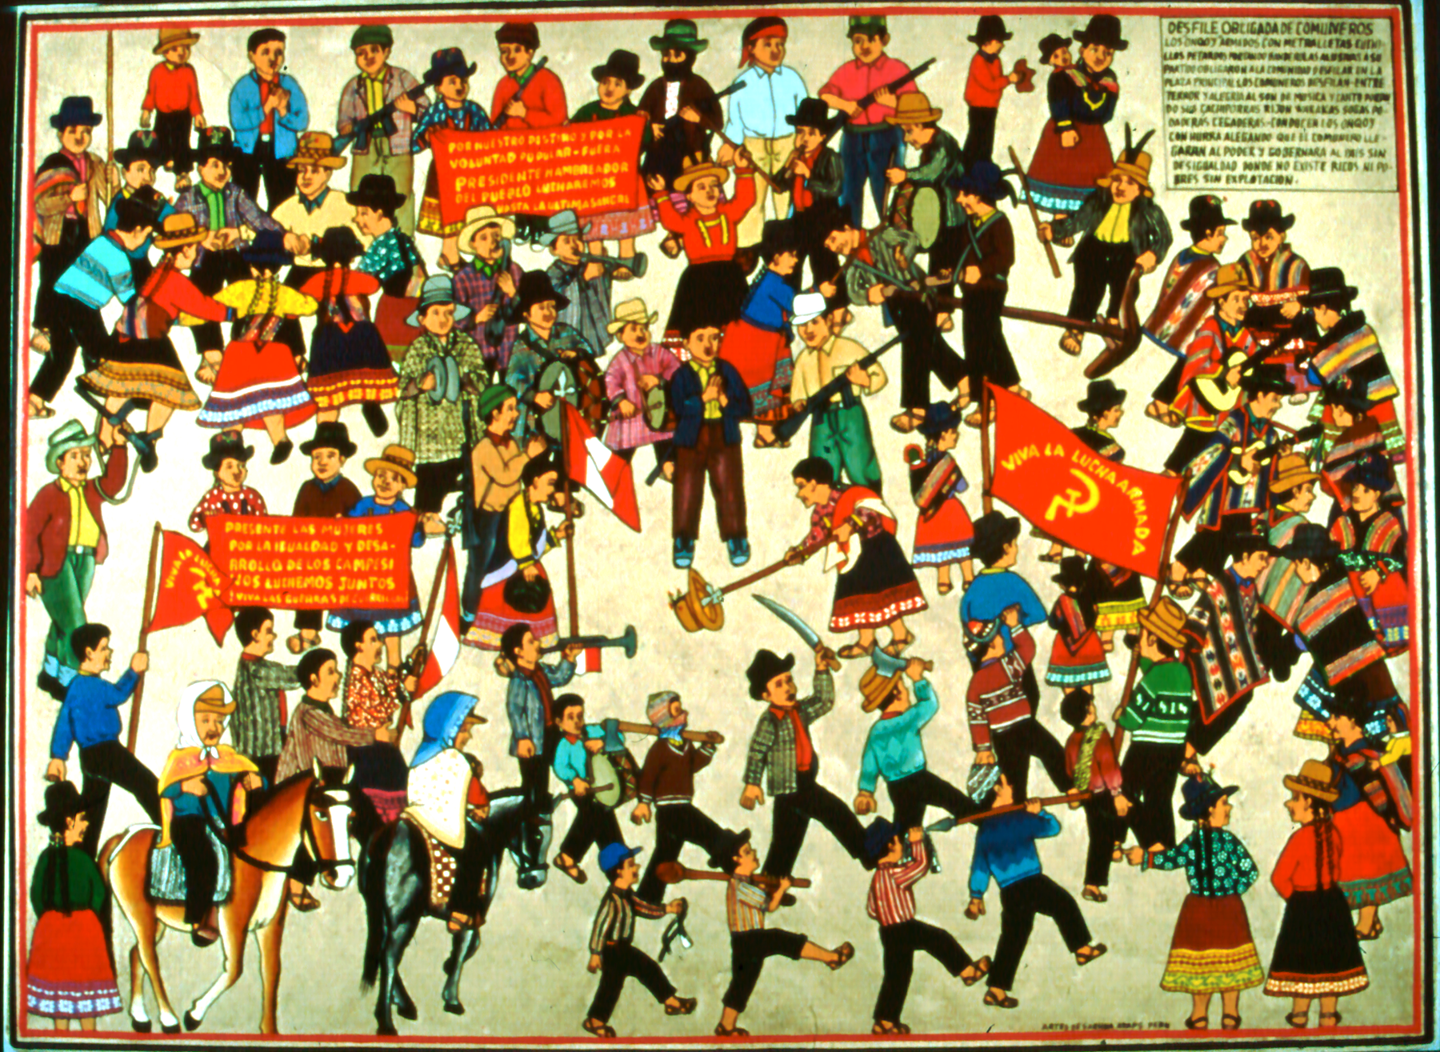

Ayacucho: Fire in the Andes

EXHIBITION FACT SHEET

ORGANIZED BY: CON/VIDA – Popular Arts of the Americas
Co-Directors: Barbara Cervenka, O.P. and Marion Jackson, Ph.D.,

DESCRIPTION: Ayacucho, an old colonial city and once center of an ancient Andean culture, became during the 1980s the site of a bitter war waged between the Maoist insurgency Shining Path and the Peruvian military during the 1980s and early 1990s. This exhibition represents the response of Andean popular artists to the conflict that destroyed lives and relationships, tore apart the fabric of traditional life in the Andea region of Peru.

The exhibition is composed of a series of 28 panel paintings, plus tapestries and retablos. The panel paintings depict events that occurred in the town of Sarhua in Ayacucho from 1980-1983 when the Shining Path attempted to infiltrate and take over the town. Painted by the group ADAPS, Asociación de Artistas Populares de Sarhua, 24 of the paintings represent an extraordinary documentation of events told from the point of view of those caught in the conflict. In addition, four later panels commisioned by Con/Vida describe the origins of Sendero Luminoso and the eventual arrest and trial of its leader, Abimael Guzman.

Retablos, wooden boxes containing painted figures, depict events that occurred during the conflict. The abstract tapestries of Edwin Sulca use bold geometric patterns and Andean symbols to encode images of the conflict and pleas for peace.

CONTENTS: A series of 28 panel paintings depicting events in Sarhua, Ayacucho, and the origins of Sendero and eventual capture of Guzman; tapestries by Edwin Sulca; retablos by Nicario Jimenez and the Brothers Blanco Bautista; photographs of the ADAPS artists and Edwin Sulca; and other documentary materials including labels and descriptive panels.
An illustrated exhibition brochure is available.

REQUIREMENTS: Approximately 300 running feet; pedestals for retablos; tapestries can be hung in central spaces or on walls.

SUPPORTED BY: Research leading to the exhibition has been supported by
Siena Heights University, Adrian, MI
Adrian Dominican Sisters
Peter Gaupp, of Neue Zurcher Zeitung, Zurich, Switzerland

TERMS: Rental: $3500.00 for eight weeks, $1000 for each additional month, plus shipping.. Exhibition travels in 6 wooden crates. Insurance value: $70,000.

EXHIBITION SCHEDULE:
Siena Heights University, Adrian, Michigan – November, 1998
University of Michigan, Ann Arbor - January, 1999.
Albion College, Albion, Michigan - November 1999
Milwaukee Institute of Art and Design – January-February, 2000
Gallery One, Washtenaw Community College – Sept-November, 2005
Swords into Plowshares Gallery, Detroit, MI – Nov-December, 2009

CONTACT: Con/Vida – Popular Arts of the Americas
440 Burroughs, Suite 365
Detroit, MI 48202 U.S.A.
Tel: 313-405-6443
Website: www.convida.org

Barbara Cervenka – bcervenk@comcast.net
Marion Jackson – mjackson@wayne.edu

